TITLE
Presenting Author,ª Co-author,^{b} Co-author^{b}
ª Affiliation, City, Country
^{b} Affiliation, City, Country
📧 email@aa.bb [presenting author's e-mail address]
Main text.^{[1,2]} Please fit the abstract onto a single page.

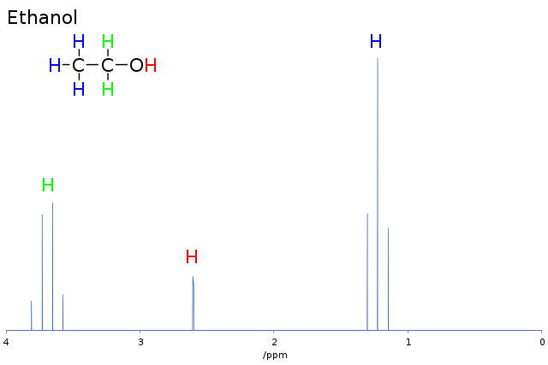
Figure 1. Description.
Acknowledgements. This work has been supported by ...
REFERENCES
[1] A. A. Surname, B. B. Surname, J. Conf. NMR 2017, 119, 12–22.
[2] B. B. Surname, A. A. Surname, J. Conf. NMR 2019, 122, 56–62.

